Last Updated: 7/5/19

Estimated Time: 1 hour

**Materials:**

* 16 samples
* Centrifuge
* 2 mL microcentrifuge tubes
* D-Glucose
* Seawater
* 1,000, 200, and 20 μL pipettes and tips (unfiltered)
* 200 μL multichannel pipette
* Vortex
* Microtitre plate
* Concentrated sulphuric acid
* 5% phenol
* Plate Reader

**Sample Preparation:**

1. Defrost samples from freezer
2. Centrifuge at 4,000 rpm (1.5 G) for 3 mins
3. Keep on ice

**Glucose Standards Preparation:**

1. Make 2 mg/mL D-glucose stock solution
2. Move 1 mL of the 2mg/mL solution into a microcentrifuge tube with 1 mL seawater labeled 1 mg/mL. Vortex.
3. Now move 1 mL of the 1mg/mL solution into a microcentrifuge tube with 1 mL seawater labeled 1 mg/mL. Vortex.
4. Repeat until you have 2, 1, 0.5, 0.25, 0.125, 0.0625, 0.03125, 0.0156, 0.078, and 0.039 mg/mL dilutions.

**Setting-up Plate:**

1. Pipette 50 μL of each glucose standard (0.25 mg/mL to 0.039 mg/mL) in wells 1-3 and 10-12 in rows A-G. *[See picture of plate layout below]*
2. Pipette 50 μL of seawater (negative control) into wells 1-3 and 10-12 of row H.
3. Pipette 10 μL of each sample in triplicate into the remaining wells (should fit 16 samples).
4. With the multichannel pipette, add 40 μL of seawater to each of the sample wells. Mix by pipetting up and down. [Note: This sample dilution could change for your specific samples, but this is what worked for *S. siderea* and *P. strigosa*]
5. Move to a fume hood.
6. With the multichannel pipette, add 150 μL of concentrated sulphuric acid into column 1. Mix by pipetting up and down once.
7. Start timer.
8. After 25 secs, with the multichannel pipette, add 30 μL of 5% phenol into column 1. *(It does not have to be 25 secs-- it can be any amount of time you are comfortable with BUT the time must be consistent for every column in the plate).*
9. Repeat this for all the columns in the plate.
10. Let the plate sit for 30 sec before putting the cover back on.
11. Incubate for 5 min in 90°C water bath.
12. Incubate for 5 min on room temp beads.

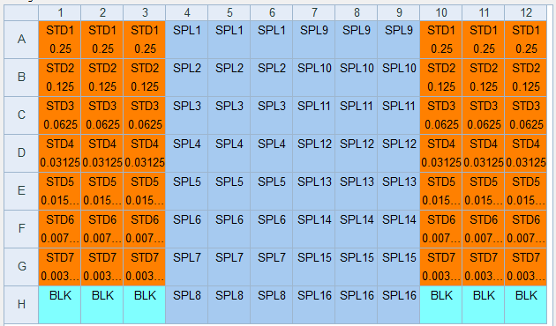

**Operating the Spec:**

1. Open Gen5 computer program.
2. Click on the template called “Carb Assays.”

*If this template is not on your computer, set up the plate layout manually using steps 3-10. If the template is on your computer, you can ignore steps 3-10.*

1. Click New Task → New → Read → OK
2. Change the absorbance wavelength to 490 → OK
3. Click Cancel when Load Plate window appears.
4. Protocol → Plate Layout → Select “Blanks,” “Standard Curves” and “Samples” → Next
5. For Standard Curves, make the factor 0.5. Type 0.25 for STD1 and then fill the concentrations for STD 2-7 by using the down arrow on the keyboard. → Next
6. Change Sample replicates to 3 → Next
7. Fill in the plate by selecting BLK, STD, or SPL on the left and dragging where they are located inside the plate → OK
8. Click the green play icon.
9. Load plate into the carousel and press OK.
10. Export data as Excel file when given the option after plate is read.
11. Take the plate out and push the plunger on the reader to close the carousel.
12. Dispose of plate in proper waste container in the fume hood.

**Analysis**

1. Create a standard curve by plotting the corrected absorbances (Blank 490) from the exported Excel file vs the known concentration of each standard. The equation of this plot can be used to convert the raw absorbances into concentrations of carbohydrates.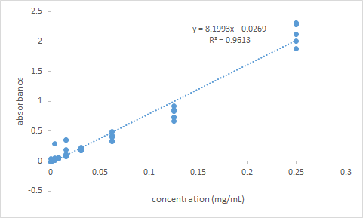
2. A corrected concentration of carbohydrates can be calculated using a dilution factor. The dilution factor is the ratio of liquid originally in a well:sample added.
   1. For example, 10uL of sample and 40uL of seawater are added. Out of the 50uL liquid in the well, 10uL is sample. Because 50/10 is 5, the dilution factor would be 5.